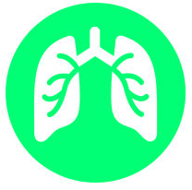 Pneumonia Panel plus, BioFire® FilmArray®

- 1 test. - 34 cibles. - Résultats en 1 heure environ.

Virus
Influenza B  Adenovirus  Coronavirus  Parainfluenza virus  Respiratory Syncytial virus | Influenza A  Human Rhinovirus/Enterovirus  Human Metapneumovirus  Middle East Respiratory Syndrome Coronavirus (MERS-CoV)*

Bactéries
Acinetobacter calcoaceticus-baumannii complex  Enterobacter cloacae  Escherichia coli  Haemophilus influenzae  Klebsiella aerogenes  Klebsiella oxytoca | Klebsiella pneumoniae group  Moraxella catarrhalis  Proteus spp.  Pseudomonas aeruginosa  Serratia marcescens  Staphylococcus aureus  Streptococcus agalactiae  Streptococcus pneumoniae

Antibiotic Resistance Genes
ESBL : CTX-M  Carbapenemases : KPC, NDM, Oxa48-like, VIM, IMP | Methicilin Resistance  mecA/mecC and MREJ
Atypical Bacteria (Qualitative)

Legionella pneumophila, Mycoplasma pneumoniae

Chlamydia pneumoniae

